**Landing Page Boxes:**

**Box 1**

**Looking for your next opportunity?**

**We are here to help you analyze your strengths, understand your potential, and find the next fulfilling move. Trust us to help you make the best of the current disruption !**

<Hyperlink> Join our Network </Hyperlink>

**Box 2**

**Is your company considering layoffs?**

You’ve clinched the purse strings as tight as possible, but layoffs are looming. Empower your employees to find new jobs

<Hyperlink> Create employee list </Hyperlink>

**Box 3**

**Looking to hire new talent?**

Come engage with and hire exceptional talent as they are calibrating afresh and finding new energy to travel an optimistic path.

<Hyperlink> Post a Job </Hyperlink>

**TABLES:**

**Heading: “Browse Jobs List”**

**Subheading: Search and apply for opportunities as companies pursuit talent like yours.**

**Heading: “Browse Candidates List”**

**Subheading: Discover exceptional talent as you grow your Organisation**

**RESOURCES**

Through years of research, we have compiled best practices, approaches and helpful guidelines for candidates and companies.

**Please ensure there is a gap and may be a different font color between the resources list and call for action button…**

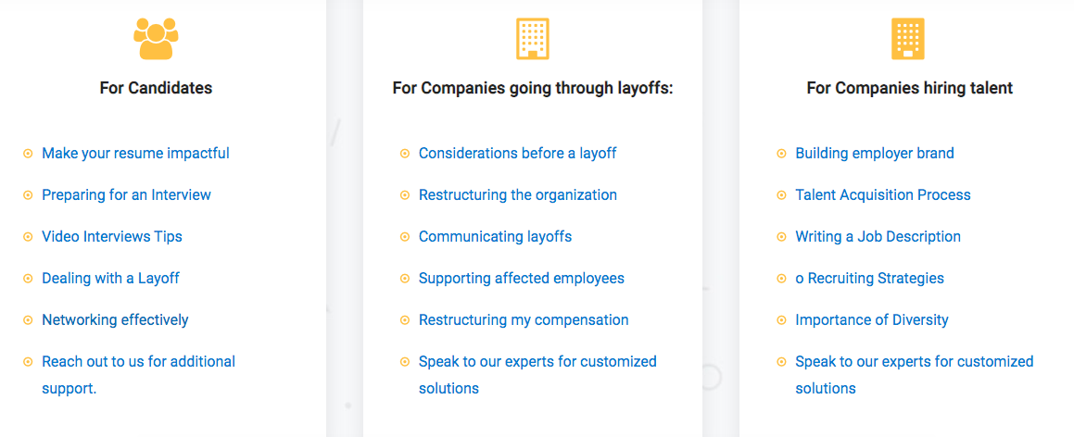

GAP

May be different Font Color

GAP

May be different Font Color

GAP

May be different Font Color

**About BounceBack List**

In early April, we began asking affected employees, companies and recruiters alike: “How can we help you during this time of uncertainty?” We learned that India needs a community of people helping each other BounceBack to their feet. BounceBack List is our first step towards helping those recently impacted by this pandemic.

Our leadership team that includes alumni of MIT and Stanford Seed, put together the learnings, resources, network & four decades of experience of OMAM with the technology of the future to create BounceBack List. We are a tech enabled, people driven platform. We use analytics, artificial intelligence and industry expertise to empower people. BounceBack List was conceptualized at the Stanford Seed leadership lab and put together with advisors from the best research institutes and industries all coming together to help companies and employees BounceBack from these challenging times.

Feel free to reach out and connect with us. Tell us how we can help do more. Expect to see more from us, as we keep building on ways to help connect and support each other.

**About OMAM**

**OMAM Consultants Pvt Ltd,** was established in 1984 as one of the pioneers HR consulting firms in the Country. **OMAM an Acronym for “Organizational Methods & Management”**has been catering to complete HR needs of organizations in the country as well as abroad. Our clients include the most recognized Indian & International Business Houses to start ups. We have been helping companies with building their teams, finding the best talent, establishing diversity practices, designing organizational structure, compensation studies, restructuring of companies, developing leadership and supporting clients through various people initiatives. With a pan India presence, over a 100 consultants and thousands of satisfied clients we have the expertise and are committed to our clients.

**Frequently Asked Questions (FAQs)**

**Where is candidate list sourced from?**

Candidates listed on our website were either provided through company submitted lists, publicly available lists or people who sign up through BounceBack List directly. In order to maintain the integrity of our community, we request everyone to follow the code of community guidelines, respect this network and support each other. If you know of any new reduction in workforce event, let us know at info@bouncebacklist.com.

**Why should I list myself?**

Misery finds company, hope finds better company. When a door is shut, it opens a window. Especially for exceptional people like you. And it’s our job to keep it that way. Find these opportunities through us. Because people who want good change to shine through after all this, are talking to us. To talk to you.

BounceBack List is being used by hiring managers across India to source talent for their companies. Additionally, our coaches and consultants will be offering regular sessions to help you get back in the right mindset and prepare you with your strategy, interview prep and resume review.

**Why do I need to create an account as a recruiter or hiring manager to use BounceBack List?**

To ensure that all outreach on BounceBack is for legitimate recruiting, we are asking all recruiters and hiring managers to register using a company account. The registration process should only take a minute and we never share your contact information with anybody on the platform.

**How do I remove myself?**

Just send us an email with the subject “Remove Me” to candidate@bouncebacklist.com and we'll remove your profile.

For any other queries, write to us at [info@bouncebacklist.com](mailto:info@bouncebacklist.com)

__________________________________________________________________________

**Bottom of the Page: is set up as 3 columns:**

Column 1 - Communication address:

137 (2nd Floor), Saidulajab, M. B Road, Mehrauli,

New Delhi - 110 030

+ 91 11-4166-8835 / 8836

***LinkedIn URL needs to be created ; facebook & twitter & Instagram***

Column 2 –

Menu in the middle should be as below:

Resources

Join our network

Browse Jobs

Create Employee List

Candidate List

Post a Job

Column 3 (right side)

**About Us**

**Contact Us**

**FAQ**

**Terms & Conditions**

**Privacy Policy**

**Community Guidelines**